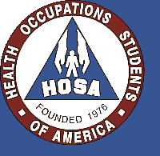
Health Occupations Students of America
BRHS 2013-2014 Application

Name:____________________________________ Age:___________
Grade:__________ Phone Number:___________________ Call or Text?:_____________
Email:________________________________________________ T-Shirt Size:______________
Parent Name:_________________________ Parent Phone Number:_________________
Student Signature:___________________________________ Date:___________________
Parent Signature:____________________________________ Date:___________________
By signing this application means that you will abide by the HOSA bylaws. There is a $30 application fee for all members. Please send the application and money to Nurse Subbiondo (Clinic). Application deadline is October 1st. All members must have a minimum 2.0 GPA to be a part of HOSA.

